Enviromental Setup for Mobile Application Development

Step1: Install NodeJS by visiting link [NodeJS](https://nodejs.org/en/download/current) or from the given link <https://nodejs.org/en/download>

Step 2: Open Terminal and run some commands to check the version

* node –v
* npm -v

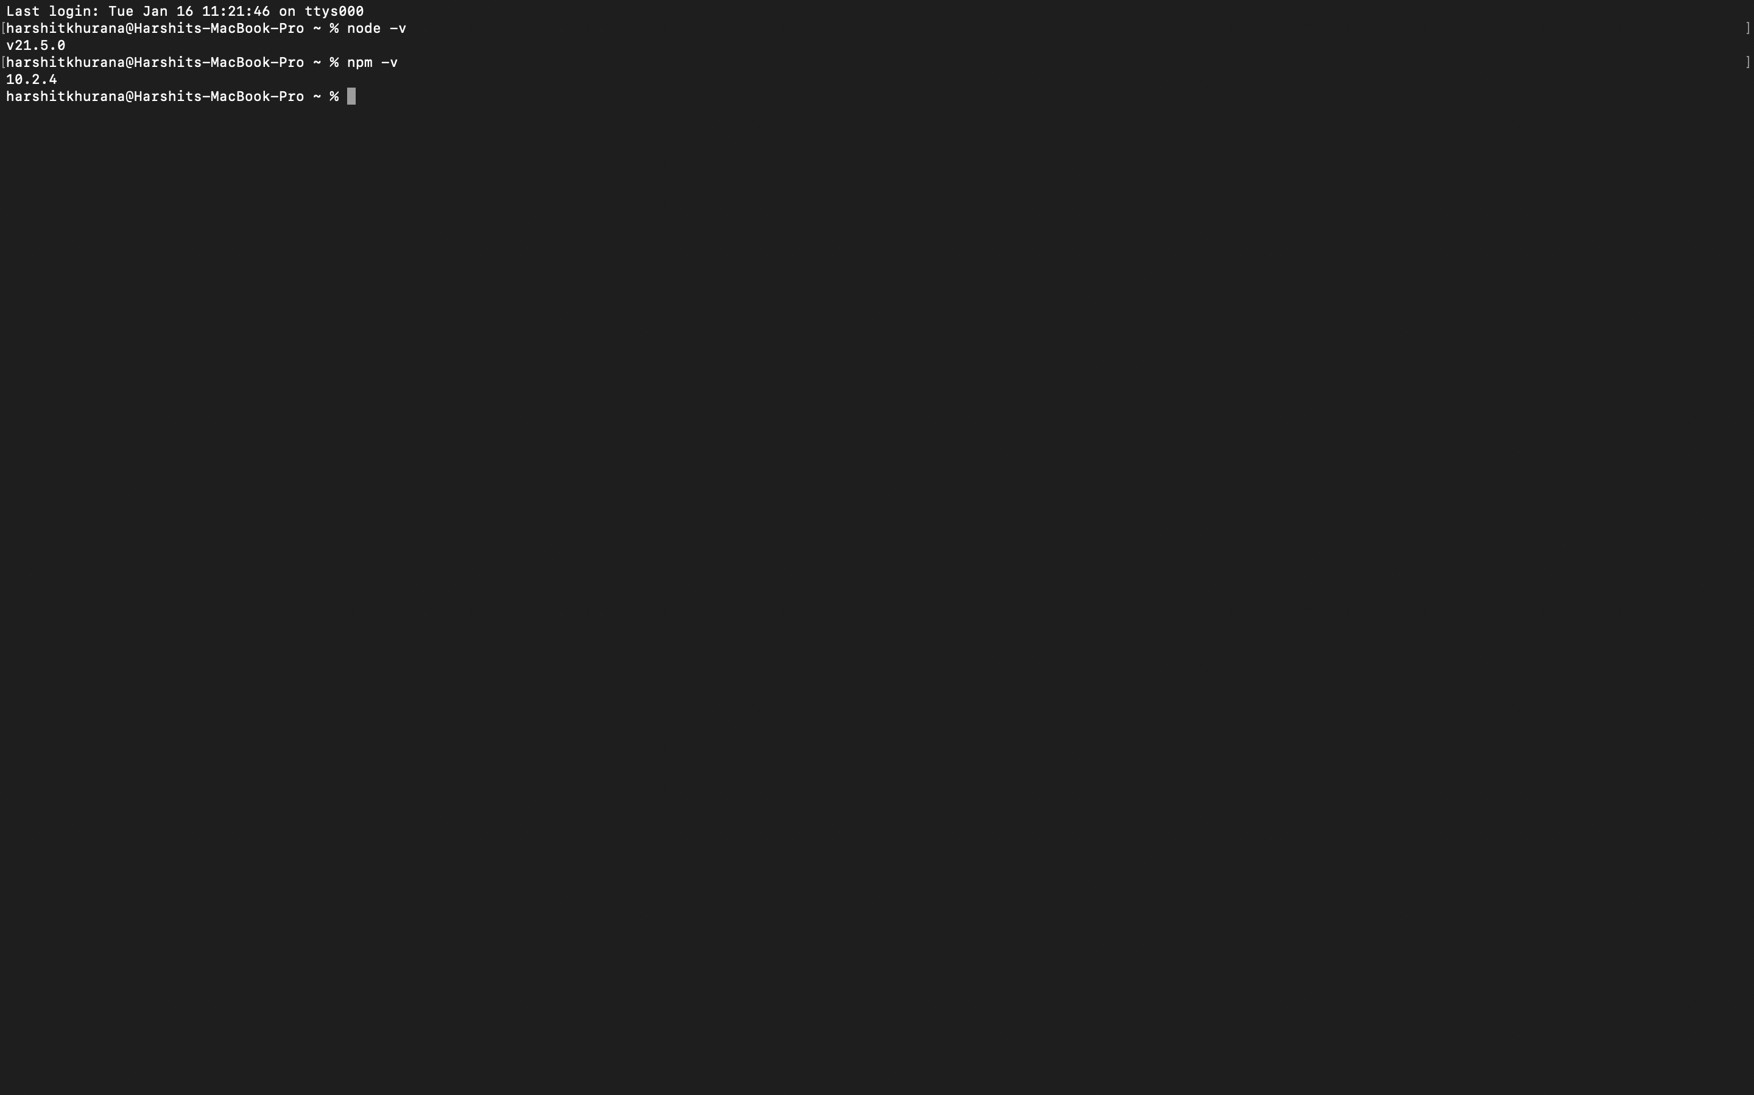

Step 3: After Installing setup, put command in terminal to install

* Npm install expo-cli-global

Step 4: Create a folder “CPRG- 303” in your laptop.

Step 5: After installing everything, create a folder that we have created using commands and paste the path

* cd /Users/harshitkhurana/Desktop/cprg303

Step 6: Run command “npx create-expo-app" @projectname to create an application in CPRG-303.

* Npx create –expo-app IncredibleToDo

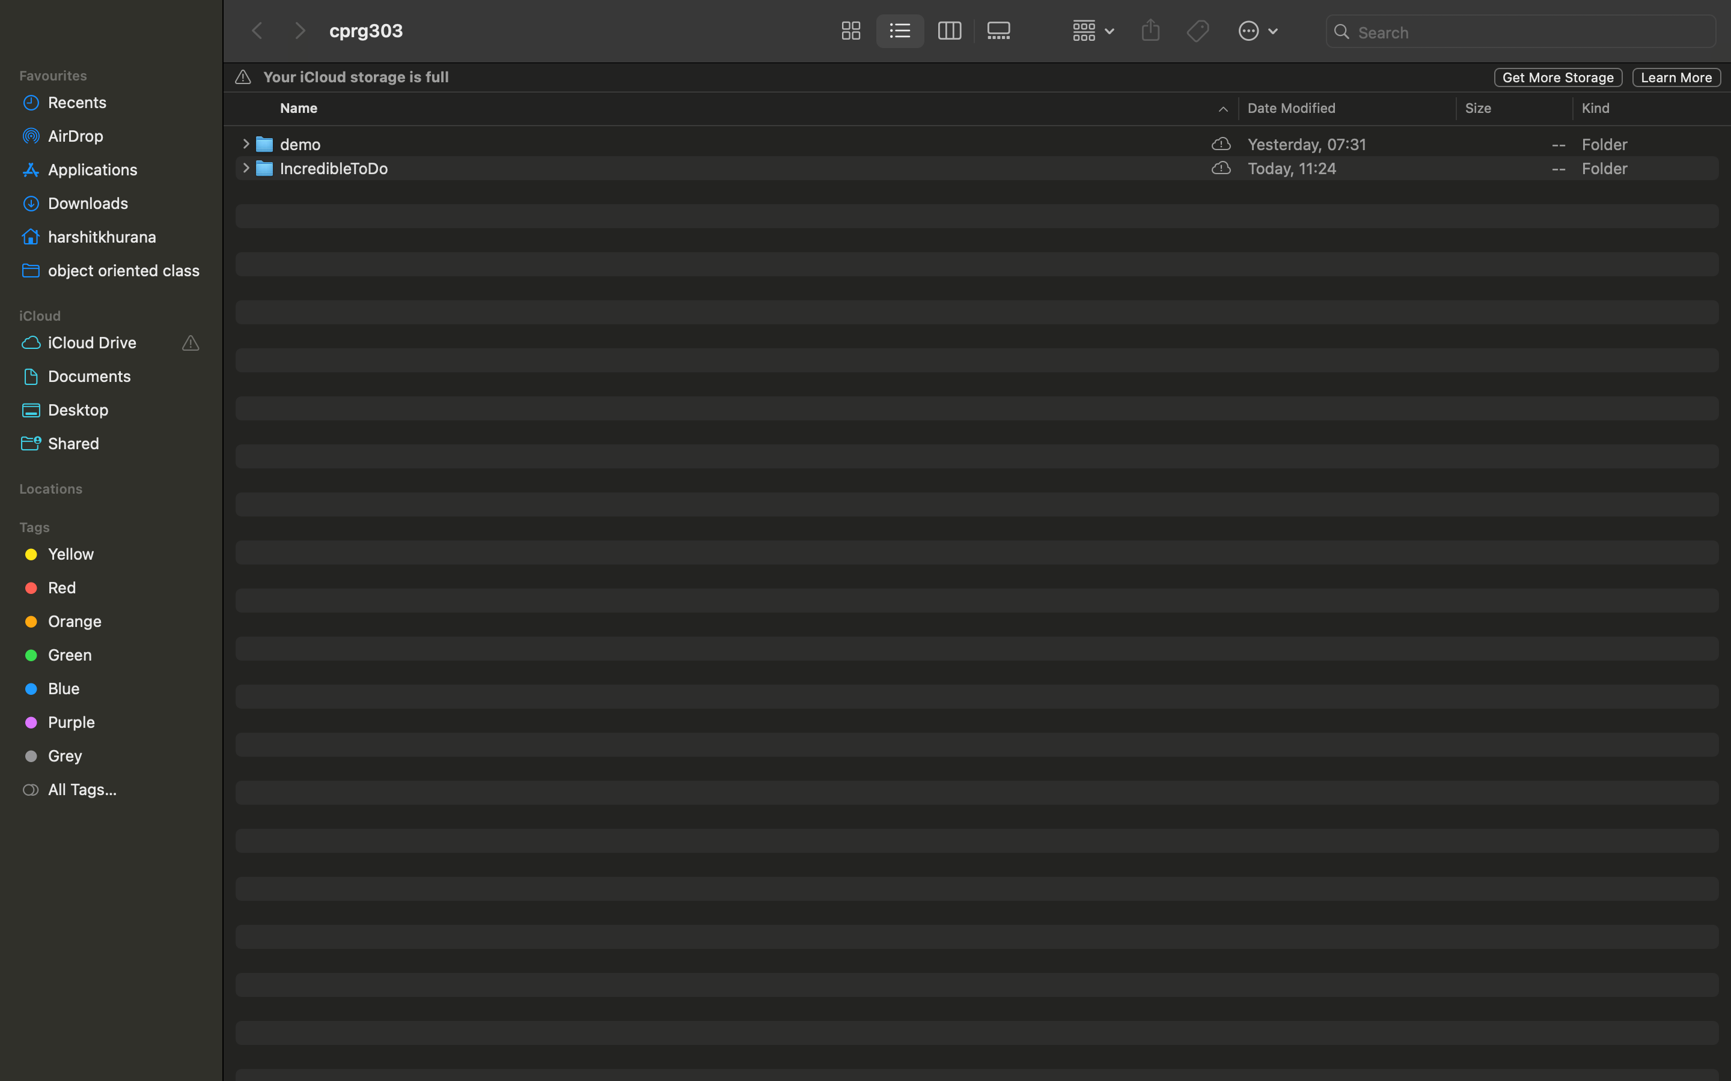

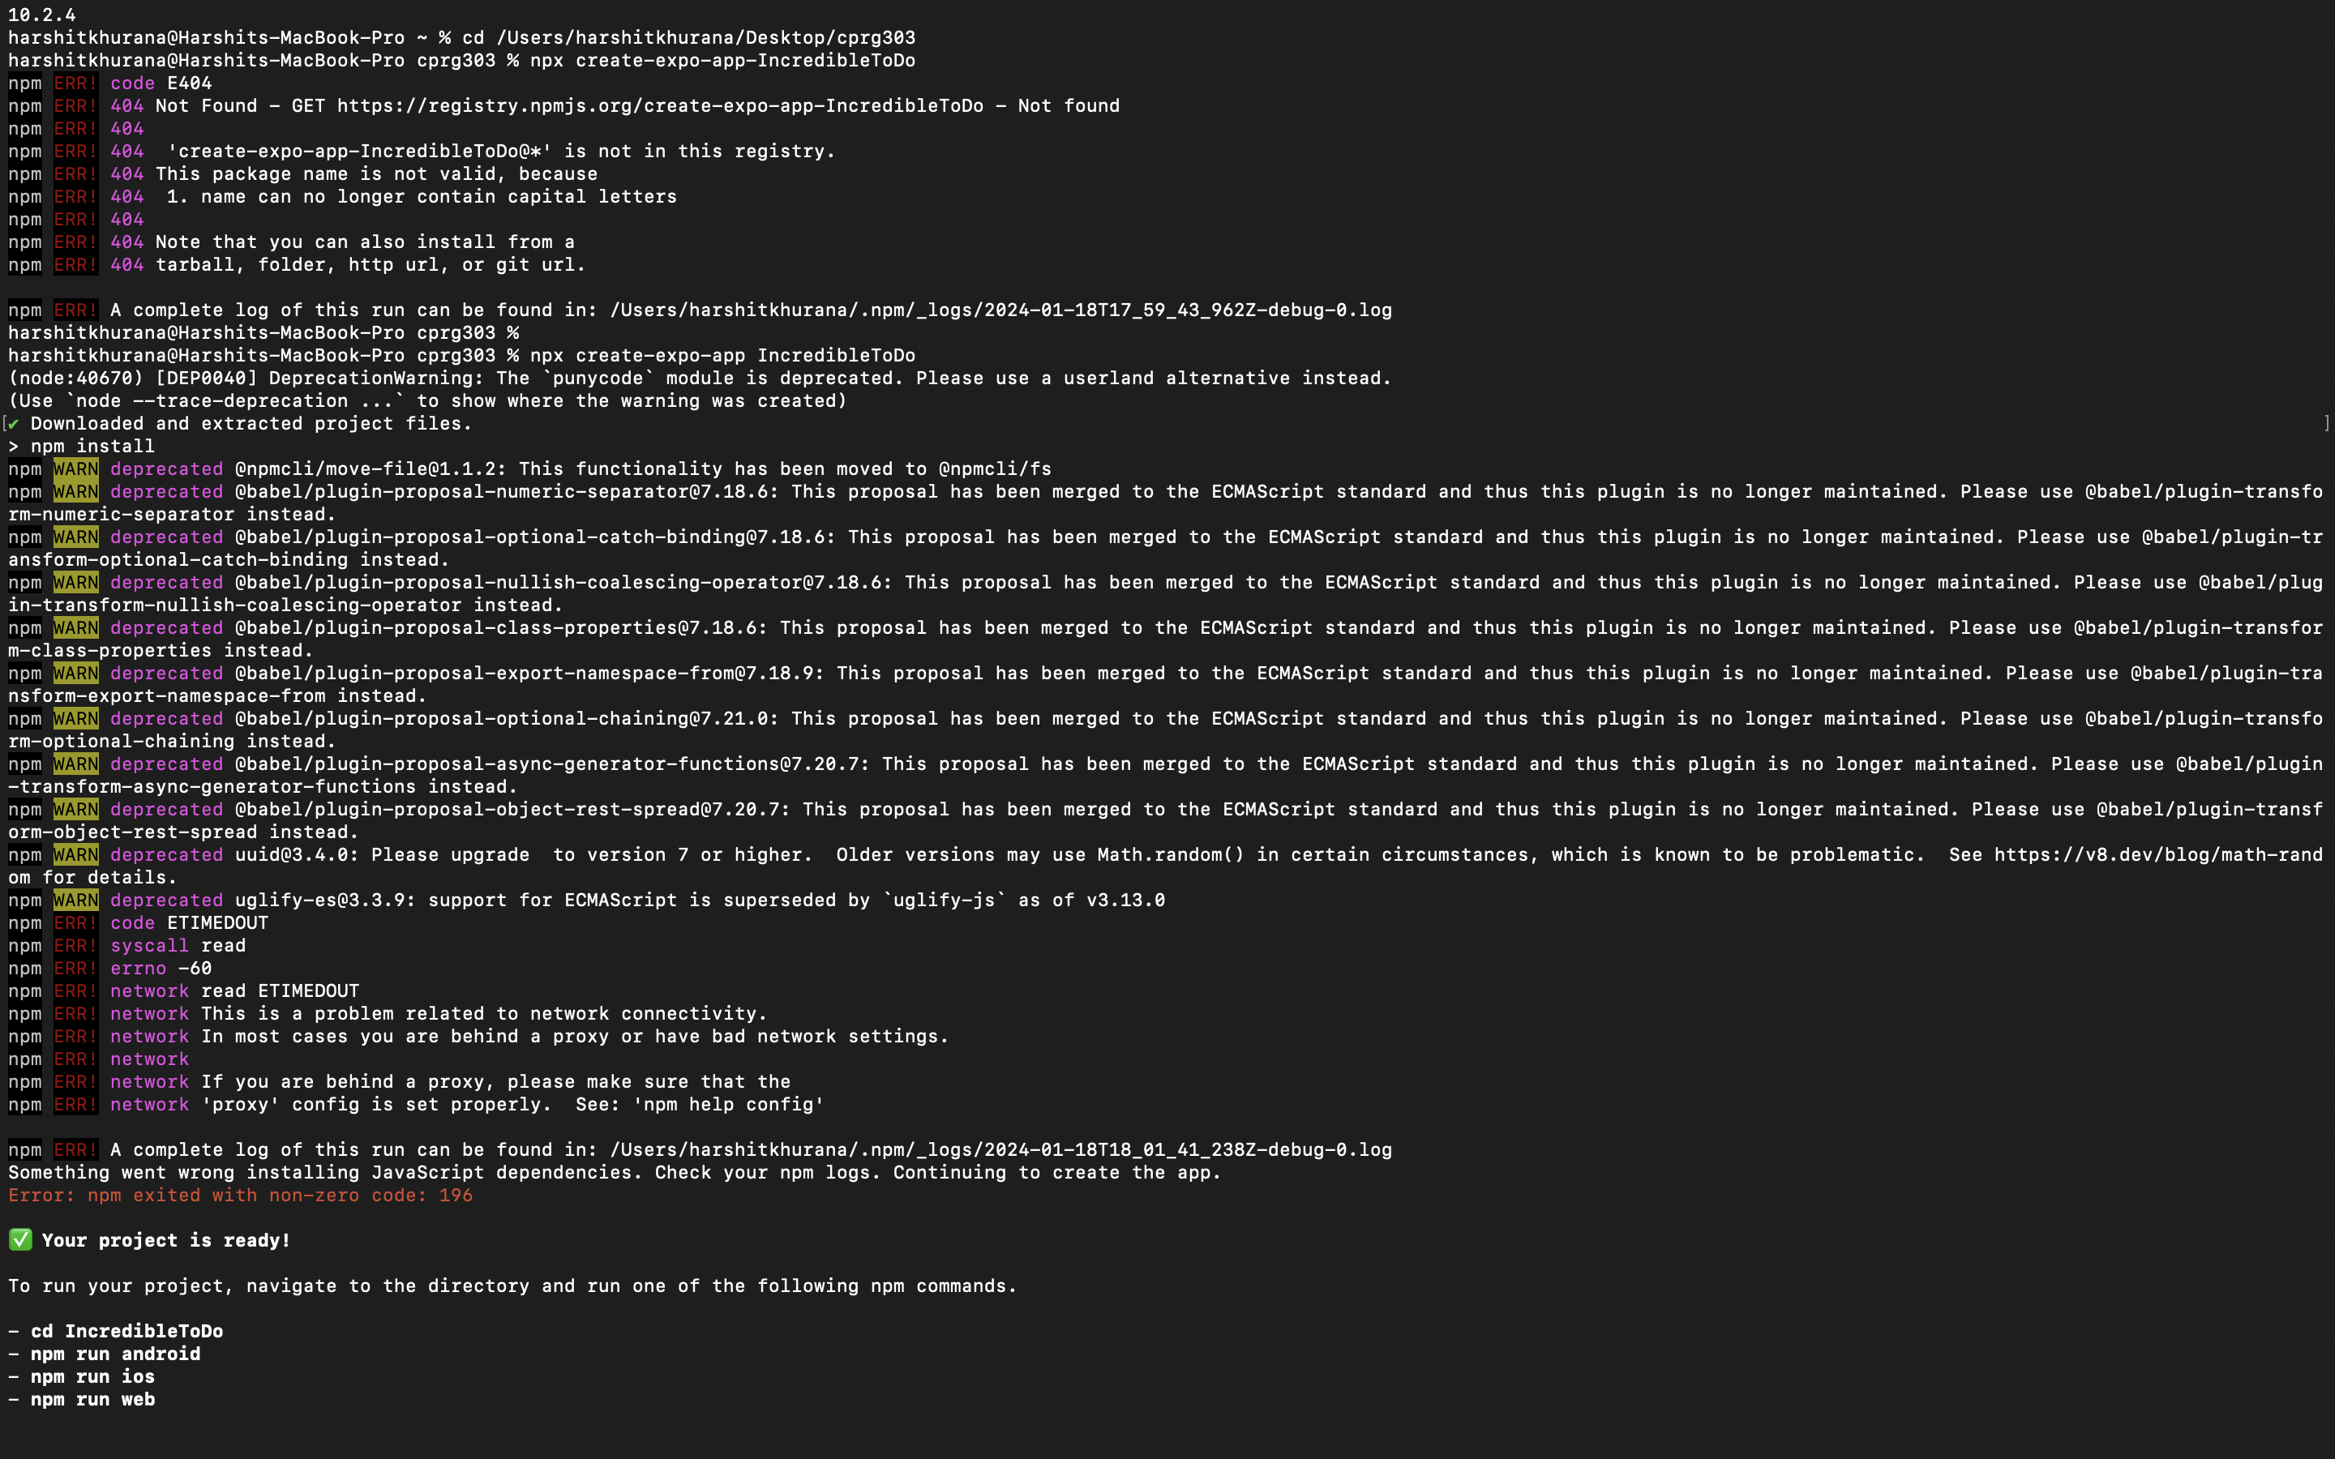

Step 7: Then We can run the commands on the Terminal to get App started we can run ”npm start”.

Step 8: We can run npm start command to get barcode.

* harshitkhurana@Harshits-MacBook-Pro cprg303%cd/Users/harshitkhurana/Desktop/cprg303/IncredibleToDo
* harshitkhurana@Harshits-MacBook-Pro IncredibleToDo % npm start

